**Computer Networks**

**Problem-solving session 7**

**IPv6 Neighbor Discovery in Cisco Packet Tracer**

**Objectives:**

Part 1: IPv6 Neighbor Discovery Local Network

Part 2: IPv6 Neighbor Discovery Remote Network

**Background / Scenario:**

In order for a device to communicate with another device, the MAC address of the destination must be known. With IPv6, a process called Neighbor Discovery using NDP or ND protocol is responsible for determining the destination MAC address. You will gather PDU information in simulation mode to better understand the process. There is no Packet Tracer scoring for this activity.

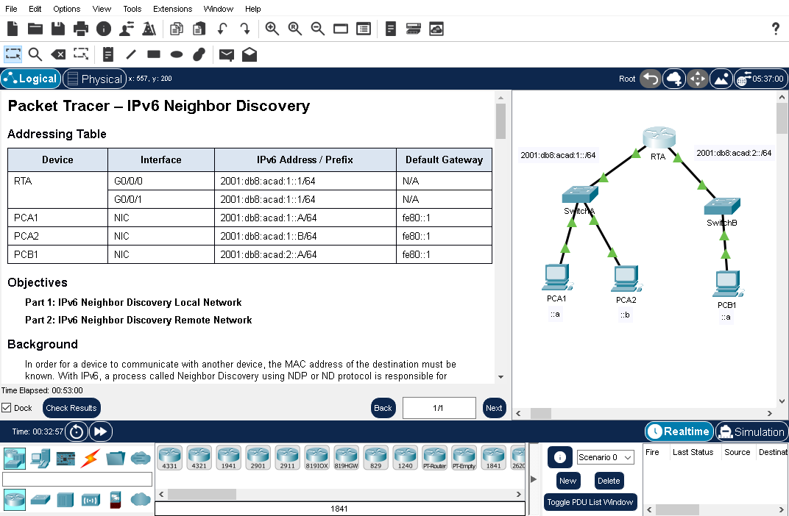

Addressing table is as follows:

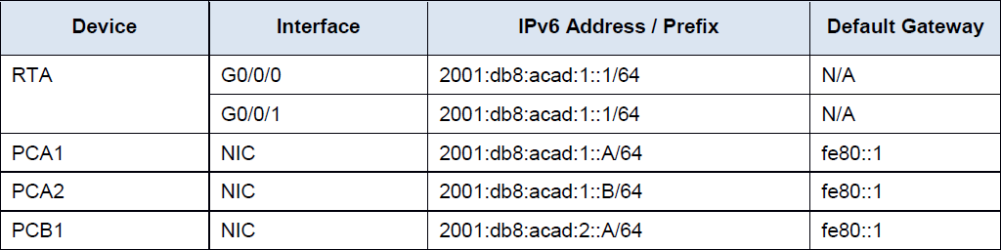

**Part 1: IPv6 Neighbor Discovery Local Network**

In Part 1 of this activity, you will obtain the MAC address of a destination device on the same network.

**Step 1:** Check the router for any neighbors that it discovered.

a. Click the RTA Router. Select the CLI tab and issue the command **show ipv6 neighbors** from the privileged exec mode. If there are any entries displayed, remove them using the command clear ipv6 neighbors.

b. Click **PCA1**, select the Desktop tab and click the **Command Prompt** icon.

**Step 2**: Switch to Simulation Mode to capture events.

c. Click the **Simulation** button in the lower right corner of the Packet Tracer Topology window.

d. Click the **Show All/None** button in the lower left part of the Simulation Panel. Make certain **Event List Filters – Visible Events** displays **None**.

e. From the command prompt on **PCA1**, issue the command **ping –n 1 2001:db8:acad:1::b**. This will start the process of pinging **PCA2**.

f. Click the **Play Capture Forward** button, which is displayed as an arrow pointing to the right with a vertical bar within the Play Controls box. The status bar above the Play Controls should read Captured to 150. (The exact number may vary.)

g. Click the **Edit Filters** button. Select the IPv6 tab at the top and check the boxes for **ICMPv6** and **NDP**. Click the red X in the upper right of the Edit ACL Filters window. The captured events should now be listed. You should have approximately 12 entries in the window. Why are ND PDUs present?if pca1 wants to send icmpv6 to the pc 2, it needs the mac address which is ndpdu user request.

___________________________________________________________________________

h. Click the square in the Type column for the first event, which should be **ICMPv6**. Because the message starts with this event there is only an Outbound PDU. Under the OSI Model tab, what is the Message Type listed for ICMPv6?**echo message type 128**

___________________________________________________________________________

Notice there is no Layer 2 addressing. Click the **Next Layer >>** button to get an explanation about the ND (Neighbor Discovery) process.

i. Click the square next to the next event in the Simulation Panel. It should be at device PCA1 and the type should be NDP. What changed in the Layer 3 addressing? The destination IP has changed: multi cast address FF02::1:FF00:B

___________________________________________________________________________

What Layer 2 addresses are shown?source MAC address 0001.427E.E8ED and destination address 3333.FF00.000B

___________________________________________________________________________

When a host does not know the MAC address of the destination, a special multicast MAC address is used by IPv6 Neighbor Discovery as the Layer 2 destination address.

j. Select the first **NDP** event at SwitchA. Is there any difference between the In Layers and Out Layers for Layer 2?NO there isnt any differences

___________________________________________________________________________

k. Select the first NDP event at PCA2. Click the Outbound PDU Details. What addresses are displayed for the following? **Note:** The addresses in the fields may be wrapped, adjust the size of the PDU window to make address information easier to read.

Ethernet II DEST ADDR: 3333.FF00.000B

___________________________________________________________________________

Ethernet II SRC ADDR:0040.0BD2.243E

___________________________________________________________________________

IPv6 SRC IP:2001:DB8:1ACAD:1::B

___________________________________________________________________________

IPv6 DST IP:FF02::1:FF00:B

___________________________________________________________________________

l. Select the first **NDP** event at **RTA**. Why are there no Out Layers? Because the IPV6 address doesn’t match he routers address resulting in dropping the package.

___________________________________________________________________________

m. Click through the **Next Layer >>** button until the end and read steps 4 through 7 for further explanation.

n. Click the next **ICMPv6** event at **PCA1**. Does **PCA1** now have all of the necessary information to communicate with **PCA2**?yes it has all the necessary info to communicate with PCA2

___________________________________________________________________________

o. Click the last ICMPv6 event at PCA1. Notice this is the last communication listed. What is the ICMPv6 Echo Message Type?129

___________________________________________________________________________

p. Click the **Reset Simulation** button in the Simulation Panel. From the command prompt of PCA1 repeat the ping to PCA2. (Hint: you should be able to press the up arrow to bring the previous command back.)

q. Click the **Capture Forward** button 5 times to complete the ping process. Why weren’t there any NDP events? Clicking that 5 times and there isnt any NDP events because the PC already know the MAC address and it doesn’t need to use the neighboring discovery.

___________________________________________________________________________

**Part 2: IPv6 Neighbor Discovery Remote Network**

In Part 2 of this activity, you will perform steps that are similar to those in Part 1, except in this case, the destination host is on another LAN. Observe how the Neighbor Discovery process differs from the process you observed in Part 1. Pay close attention to some of the additional addressing steps that take place when a device communicates with a device that is on a different network.

Make sure to click the **Reset Simulation** button to clear out the previous events.

**Step 1:** Capture events for remote communication.

a. Display and clear any entries in the IPv6 neighbor device table as was done in Part I.

b. Switch to simulation mode. Click the **Show All/None** button in the lower left part of the Simulation Panel. Make certain the **Event List Filters – Visible Events** displays None.

c. From the command prompt on PCA1 issue the command **ping –n 1 2001:db8:acad:2::a** to ping host PCB1.

d. Click the **Play Capture Forward** button which is displayed as an arrow pointing to the right with a vertical bar within the Play Controls box. The status bar above the Play Controls should read Captured to 150. (The exact number may vary.)

e. Click the **Edit Filters** button. Select the IPv6 tab at the top and check the boxes for **ICMPv6** and **NDP**. Click the red X in the upper right of the Edit ACL Filters window. All of the previous events should now be listed. You should notice there are considerably more entries listed this time.

f. Click the square in the Type Column for the first event, which should be **ICMPv6**. Because the message starts with this event, there is only an Outbound PDU. Notice that it is missing the Layer 2 information as it did in the previous scenario.

g. Click the first **NDP** event At Device **PCA1**. What address is being used for the Src IP in the inbound PDU?FE80::201:42FF:FE7E:E8ED

___________________________________________________________________________

IPv6 Neighbor Discovery will determine the next destination to forward the ICMPv6 message.

h. Click the second ICMPv6 event for **PCA1**. PCA1 now has enough information to create an ICMPv6 echo request. What MAC address is being used for the destination MAC?0001.961D.6301

___________________________________________________________________________

i. Click the next ICMPv6 event at device **RTA**. Notice that the outbound PDU from RTA lacks the destination Layer 2 address, This means that RTA once again has to perform a Neighbor Discovery for the interface that has the 2001:db8:acad:2:: network because it doesn’t know the MAC addresses of the devices on the G0/0/1 LAN.

j. Skip down to the first ICMPv6 event for device PCB1. What is missing in the outbound Layer 2 information? The destination MAC address must be determined for ipv6 destination.

___________________________________________________________________________

k. The next few **NDP** events are associating the remaining IPv6 addresses to MAC addresses. The previous NDP events associated MAC addresses with Link Local addresses (a link-local address is a network address that is valid only for communications within the subnetwork that the host is connected to.).

l. Skip to the last set of ICMPv6 events and notice that all of the addresses have been learned. The required information is now known, so PCB1 can send echo reply messages to PCA1.

m. Click the Reset Simulation button in the Simulation Panel. From the command prompt of PCA1 repeat the command to ping PCB1.

n. Click the Capture Forward button nine times to complete the ping process. Were there any NDP events?no there arent any NDP events

___________________________________________________________________________

o. Click the only **PCB1** event in the new list. What does the destination MAC address correspond to?0001.961D.6302 Mac ADDRESS OF ROUTER interface a gigibit Ethernet 0/0/1

___________________________________________________________________________

Why is PCB1 using the router interface MAC address to make its ICMP PDUs?Because the destination device is on another network it addresses the period the default gateaway interface.

___________________________________________________________________________

**Step 2:** Examine router outputs.

a. Return to **Realtime** mode.

b. Click **RTA** and select the CLI tab. At the router prompt enter the **command show ipv6 neighbors**. How many addresses are listed?

4 addresses are listed

What devices are these addresses associated with?

PCA1 and PCB1

Are there any entries for PCA2 listed (why or why not)?its not listed as it hasnr communicated across the network

___________________________________________________________________________

c. Ping **PCA2** from the router.

d. Issue the **show ipv6 neighbors** command. Are there entries for PCA2?

_yes there is

**Reflection Questions**

1. When does a device require the IPv6 Neighbor Discovery process?w**hen the destination is unknown**

2. How does a router help to minimize the amount of IPv6 Neighbor Discovery traffic on a network?it keeps the neighbors table and it doesn’t initiate ND for destinations hosts

3. How does IPv6 minimize the impact of the ND process on network hosts?it uses multi cast addresses

4. How does the Neighbor Discovery process differ when a destination host is on the same LAN and when it is on a remote LAN?when it is in the same LAN only the device that matches the ipv6 address response and other devoces drop the packets. When it is remote, the gateaway device provides the MAC address of the interface for the destination Mac and searches for MAC address on the remote network

___________________________________________________________________________